## Problem 1:

Source Code: Submitted

Output:

---PersonTable---

[FID=1, dob=12.11.89, name=Hoffman, zip=66133]

[FID=2, dob=04.01.93, name=Mayer, zip=67663]

[FID=3, dob=11.11.89, name=Hofmann, zip=66123]

[FID=4, dob=01.04.1993, name=Mayer, zip=67653]

[FID=5, dob=01.04.1993, name=Meyer, zip=67663]

-----------------

---ProbabilisticPersonTable---

[dobs={11.11.89=0.4, 12.11.89=0.6}, fids=[1, 3], names={Hoffman=0.6, Hofmann=0.4}, zips={66123=0.4, 66133=0.6}]

[dobs={01.04.1993=0.7, 04.01.93=0.3}, fids=[2, 4, 5], names={Meyer=0.5, Mayer=0.5}, zips={67663=0.8, 67653=0.2}]

-----------------

All checks passed, solution probably correct.

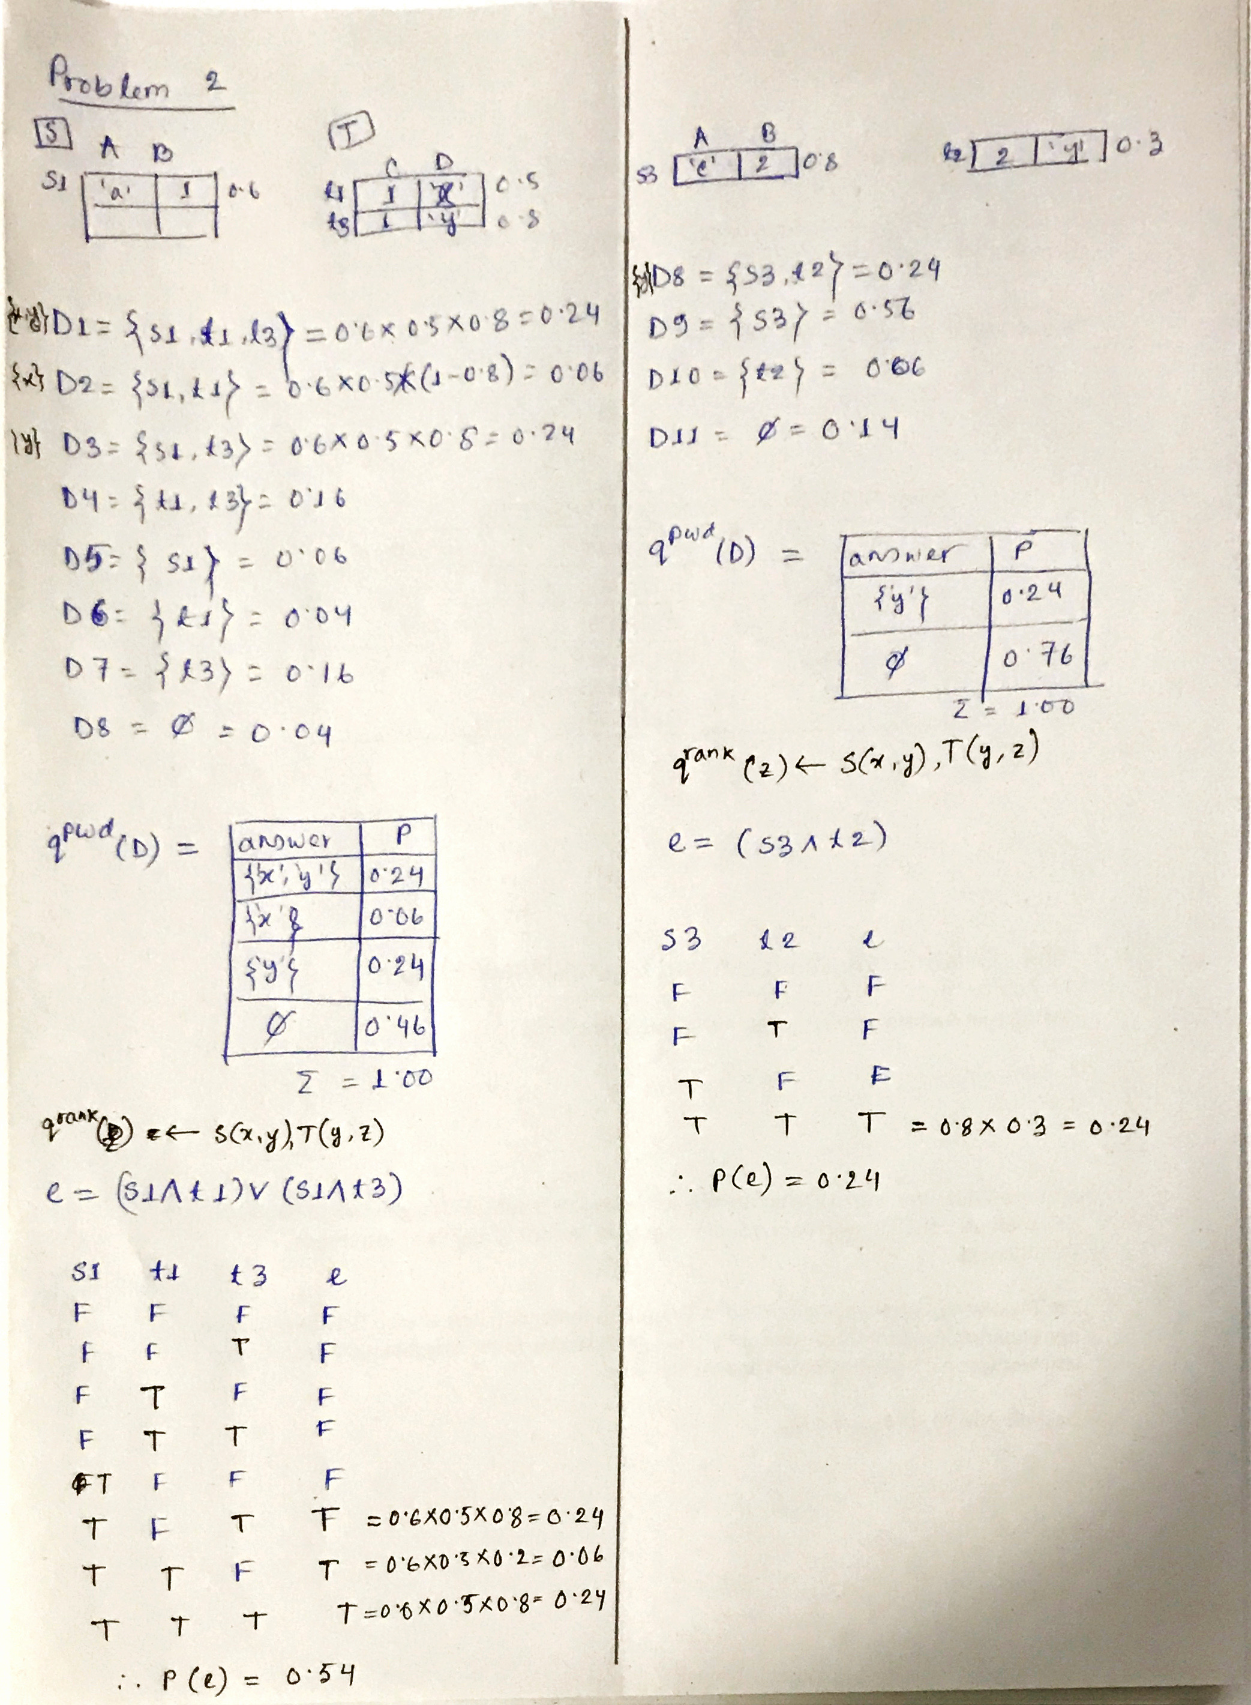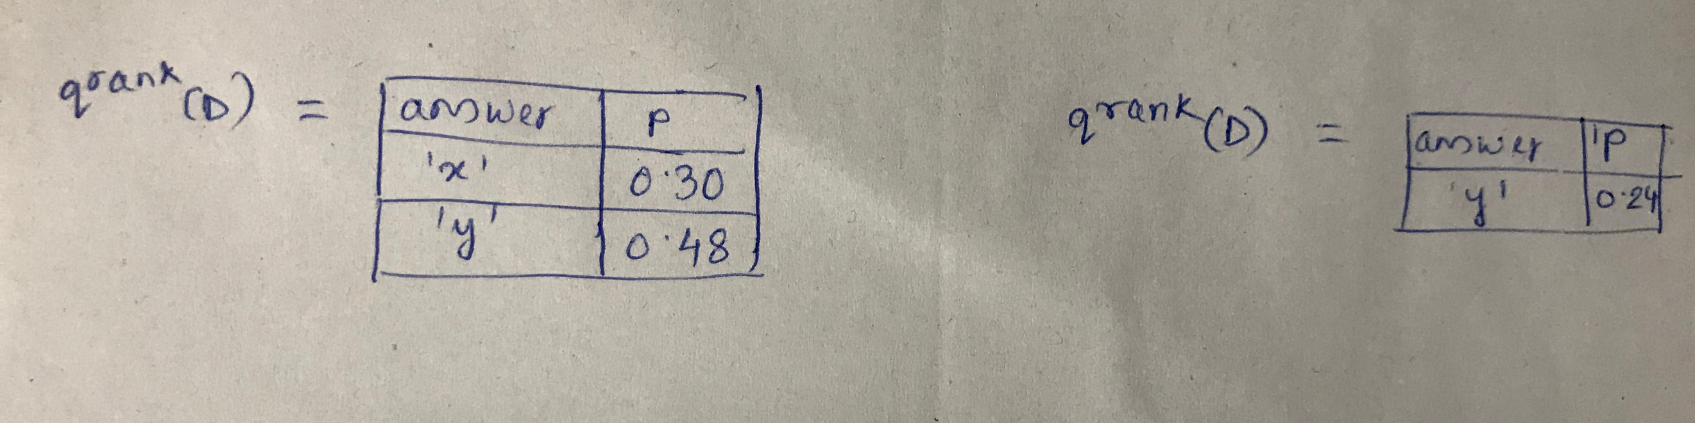

### Problem 3:

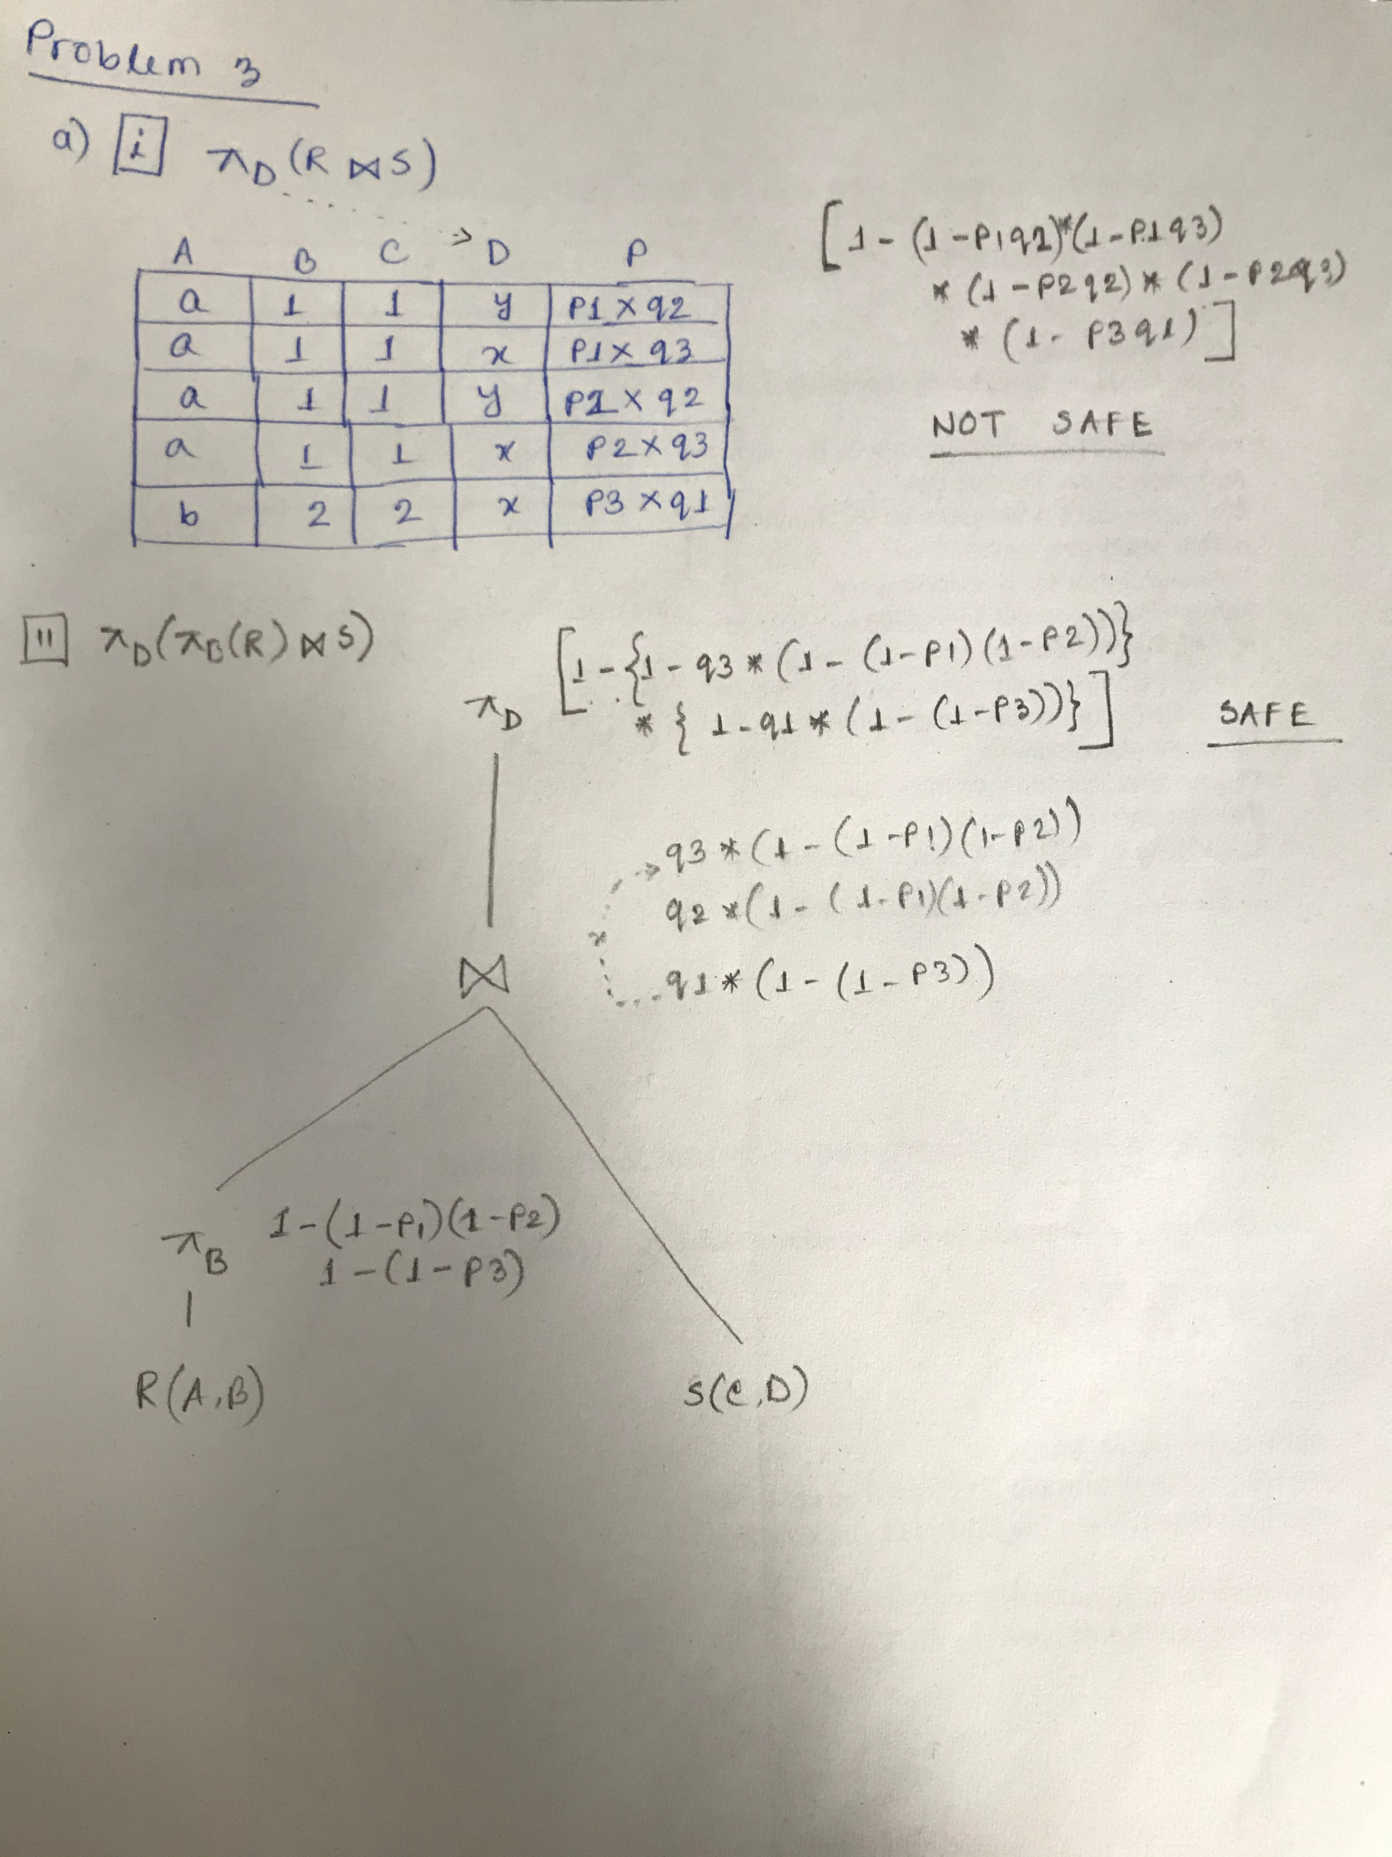

b)

|  |  |
| --- | --- |
| **not safe** | |
| select 1-prod(1-r.p*s.p) as prod  from r, s  where r.x=s.x | 0.80368740352 |
|  | |

|  |  |
| --- | --- |
| **safe** | |
| select ss.x, r.z, 1-(prod(1-(r.p * ss.p))) as prod  from r, (select s.x, prod(1-s.p) as p from s group by s.x) as ss  where r.x=ss.x  GROUP BY ss.x, r.z | Total ~= 0.686 |
|  | |

## Problem 4:

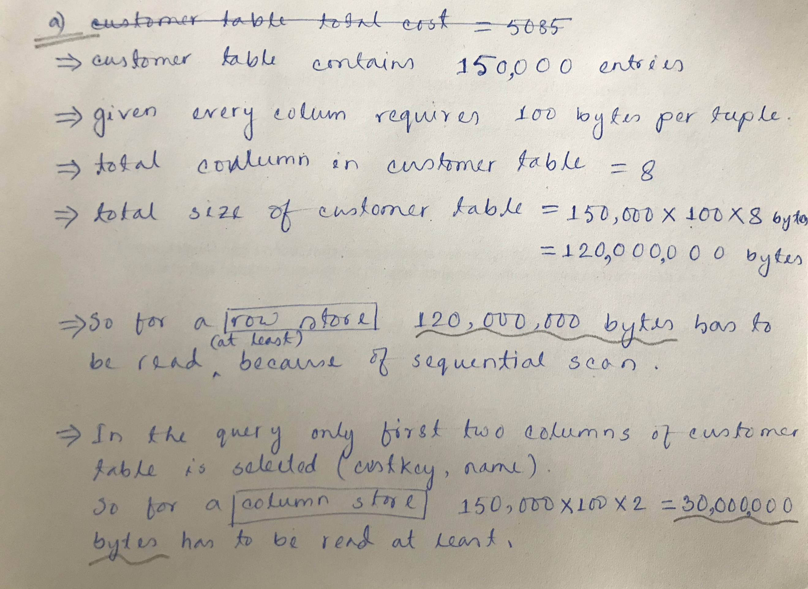

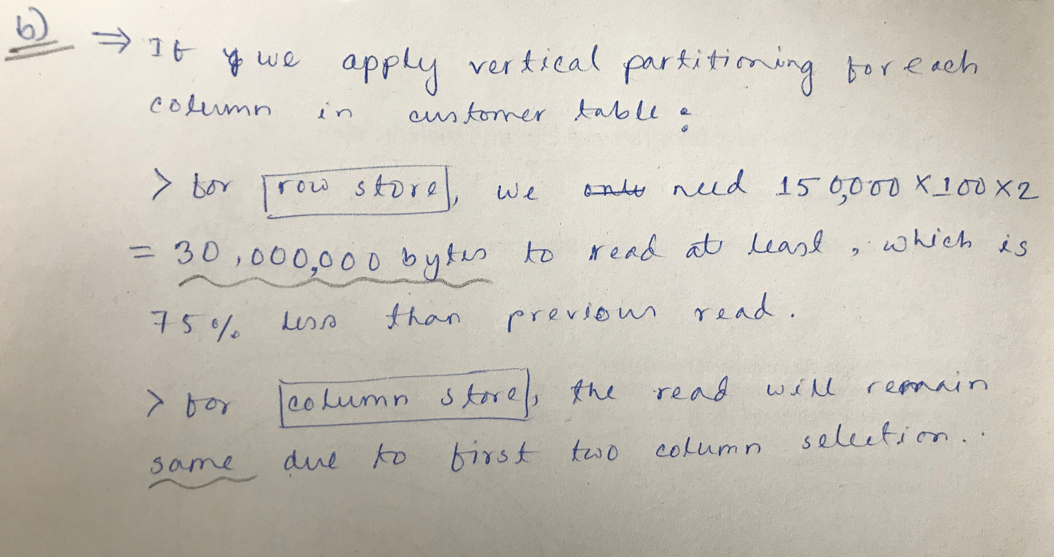

## Problem 5:

